# Place Value (up to 999)

1. Write the number that has **4 hundreds, 6 tens, and 3 ones**.

__________________

1. What number is in the **tens** of **572**?

__________________

1. Put these numbers from **most** to **least**: 648, 725, 601

__________________

1. Write the number that comes **after** **398**.

__________________

1. How much is the **8** in **683**?

__________________

# Counting in 2s, 3s, 5s, 10s

1. Count by +**2** from **14** until **26**.

14, ____________________________________, 26

1. Count by +**5** from **35** until **15**.

35, ____________________________________, 15

1. What is **after 63** when **counting by +3**?

__________________

1. Count by +**10** from **70** until **120**.

70, ____________________________________, 120

1. Which numbers are **missing**?:

45, ________, 51, ________, 57

# 100 More/Less

1. What is **100** **more >** than **256**?

__________________

1. What is **100** **less <** than **492**?

__________________

1. 675 + 100 = ?

__________________

1. 100 - 327 = ?

__________________

1. Fill in the blank: __ - 100 = 622

__________________

# Multiplying by 2, 3, 5, 10

1. 6 x 2 = ?

__________________

1. 4 x 5 = ?

__________________

1. 10 x __ = 30

__________________

1. 3 x 7 = ?

__________________

1. 8 x __ = 24

__________________

Fractions

1. Colour ½ of the rectangle.
2. What fraction of the circle is green?

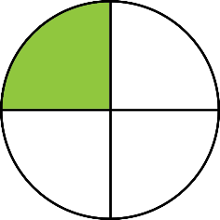

__________________

1. Draw a square and show ¾.
2. $\frac{2}{6} and \frac{3}{9}$ are the **same fraction**, write **another fraction** that is the **same**

__________________

1. Is $\frac{5}{5}$**more >**, **less <** or **equal =** to **1**?

__________________

# Time (o'clock, half past, quarter past/to)

1. 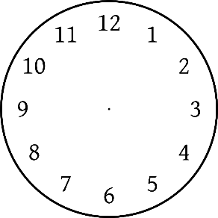Draw the **hands** to show **7 o'clock**.
2. **Circle** the clock that shows **quarter past 2**?

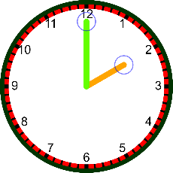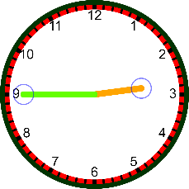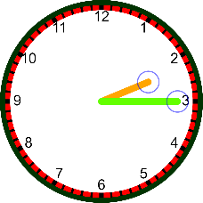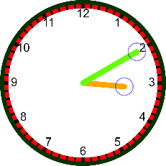

1. **Draw** the **hands** to show **half past 11**.

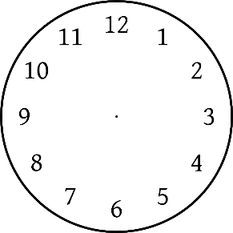

1. **Circle** the clock that shows **quarter to 5**?

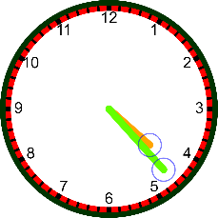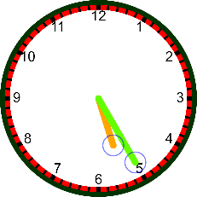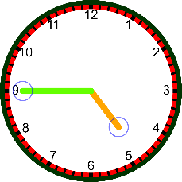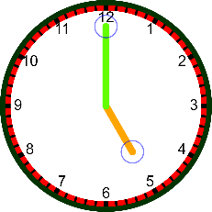

1. **Draw** the **hands** to show 9:00.

